**KNN model analysis**

For this model, we first removed the date and time column form the dataset. We then converted all the variables into numeric except the target variable (global_active_power).

We divided the target variable into 3 categories:

0 – 11.67 = Low 11.68 – 40 = Medium >40 = High

And converted them to factor

We also converted the global_active_power and global_reactive_power columns into watt since they were in kilowatt.

We divided the dataset into train and test in the ratio 80:20 ratio. We trained the model on 80% and tested it on test data.

After applying the model on the dataset, our predictions were:

For this model, our accuracies and other measurements were:



**SVM model analysis**

We used the same model from KNN analysis with the target variable converted into categorical variable and then into factor with 3 levels.

After applying the model on the dataset, our predictions were:

Our model evaluation was:

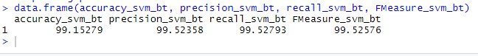

Which was higher than knn.